Linear Investigation
International Mobile Phone

The table shows the linear relationship between the length of a mobile phone call and the cost of the call.

BEBO INTERNATIONAL MOBILE PHONE PLAN

Length of call (minutes) | 1 | 2 | 3
Cost (dollars) | 7.6 | 14.4 | 21.2

6. [2 marks]
Draw the graph of the mobile phone plan on the axis provided.
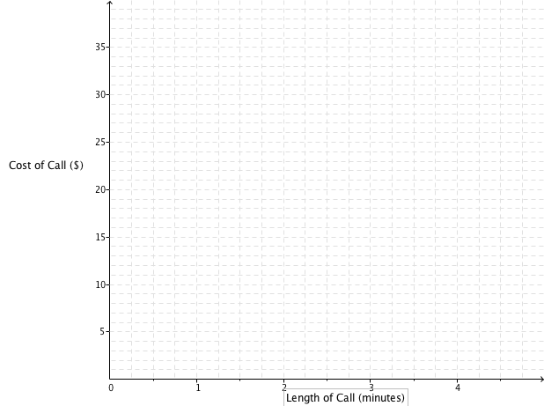

7. [1 marks]
What is the cost of a 4-minute phone call on this BEBO mobile phone plan?

8. [2 marks]
What is the cost per minute for the BEBO phone calls?

9. [3 marks]
What is the rule to calculate the cost (c) of a phone call of “m” minutes on the BEBO mobile phone plan?

10. [3 marks]
GINTS international mobile phone plan uses the formula c=3.4m+11. Draw this on the graph above.

11. [2 marks]
Which mobile plan is better if I plan to make a phone call of 1 ½ minutes. How much better would it be?

12. [2 marks]
What length of call are the two plans the same cost? What is the cost at this time?

13 [3 marks]
A third phone company wishes to enter the market as the cheapest phone plan for the first hour. They are not charging a line rental fee. What would be the maximum rate they could charge to be able to make this claim?

